Class Room Practice sheet

Name: Akshay Gaur
Phone number: 9311211182
Batch: DA 6

🟢 EASY – Q1
Show all students with their course names (if they have any).

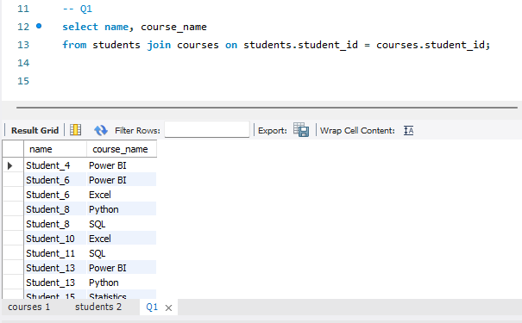

🟢 EASY – Q2
Show students who have not enrolled in any course.

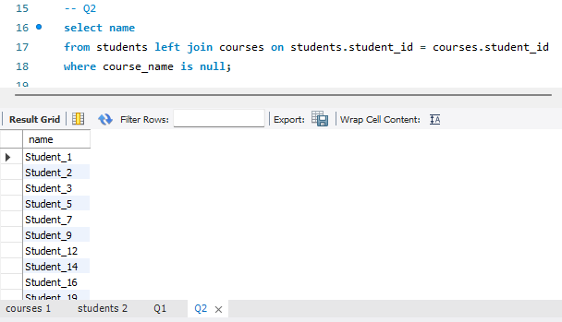

🟢 EASY – Q3
Show all courses along with student names.

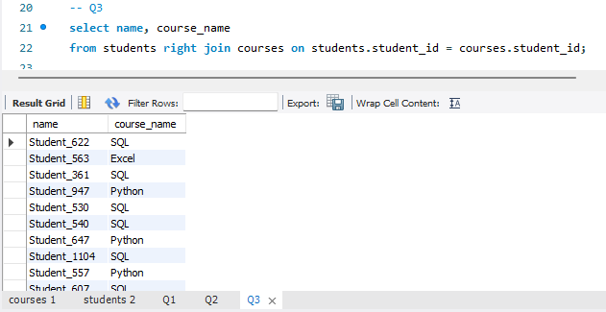

🟢 EASY – Q4
Display students from 'Pune' along with their enrolled courses.

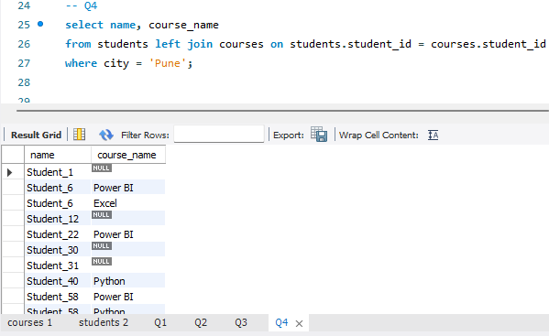

🟢 EASY – Q5
Display students who scored more than 80 marks and their courses.

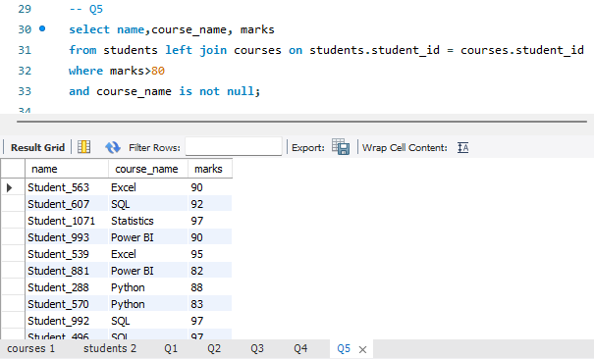

🟡 MEDIUM – Q6
Find total number of students enrolled in each course.
(Use JOIN + GROUP BY)

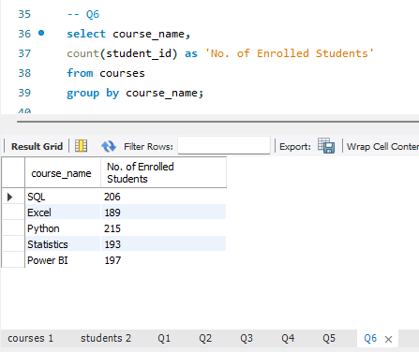

🟡 MEDIUM – Q7
Show only those courses where more than 50 students are enrolled.
(JOIN + GROUP BY + HAVING)

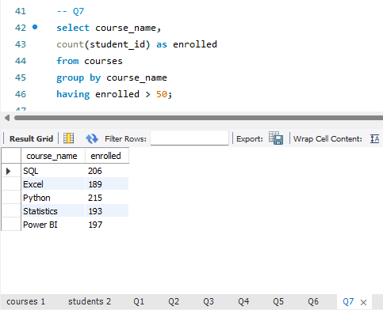

🔴 HARD – Q8
Find cities where the average marks of students enrolled in 'Python' course is greater than 60.

